chart repository is like docker hub where we can store our charts and pull down and below are the extensions we need add in visual studio code

* azure k8s
* k8s support
* yaml
* non breaking space highlighter

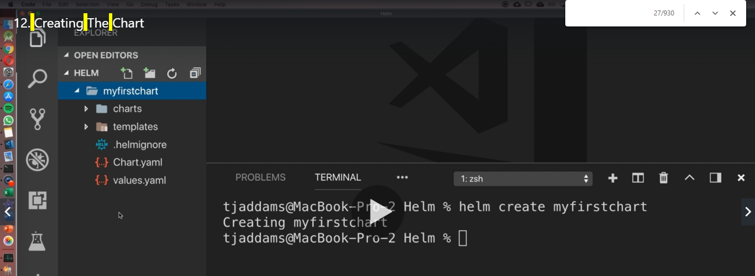

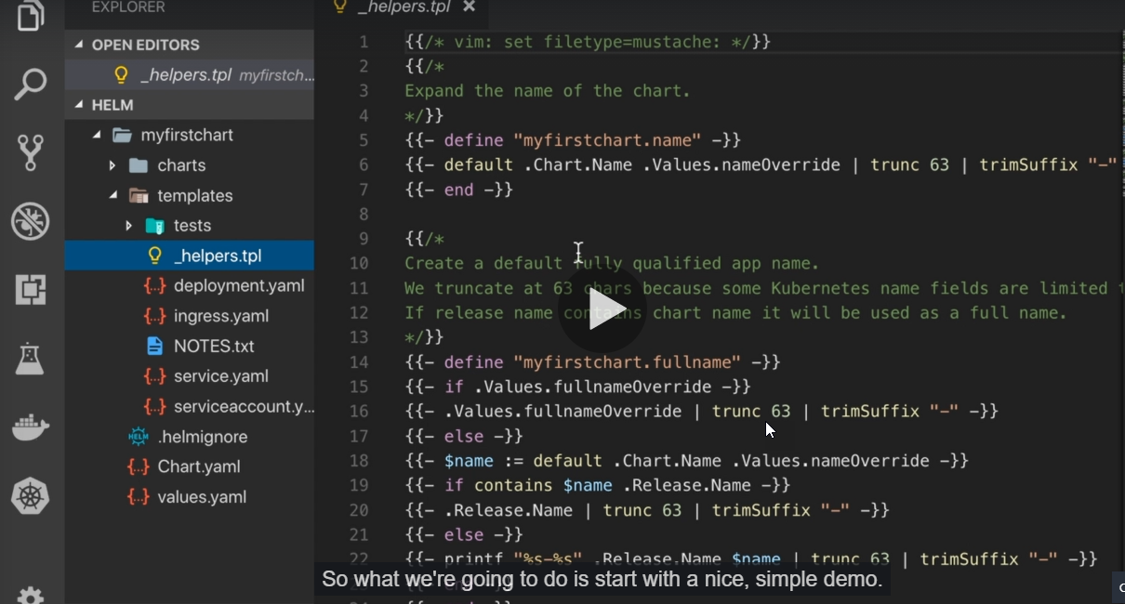

We can see lots of lines it with two curly braces and something inside ( in deployment and ingress), and this is where the templating is happening. So what's going to happen is we'll set values in this fall here. Values.Yaml

We also have a helper file that's useful for setting the name of things or setting variable.

Create the chart

Like I said, it's one command and it's going to set all of us up. We need to give our chart a name. So I'm going to call it my first chart and then we need to pass in the path. In this case, I'm going to use full stop. What it's going to do is it's going to say, I want you to create a chart from the folder I'm in right now. Now, if I command in place, let's go ahead and hit enter. Awesome.

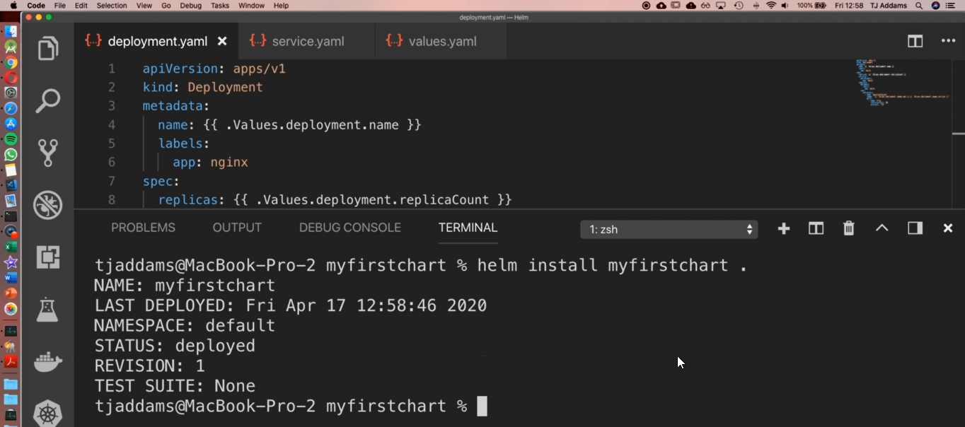

Now, let me show you how we can go ahead and see it.



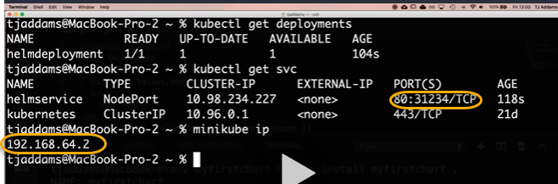

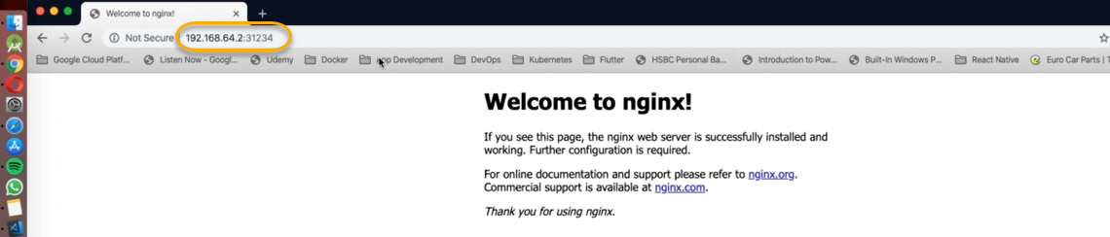

Minikube:nodeport

Metadata

Lables

App: nginx

Spec

Match labels

App: nginx

Template

Metadata:

Lables:

App: nginx

Troubleshoot

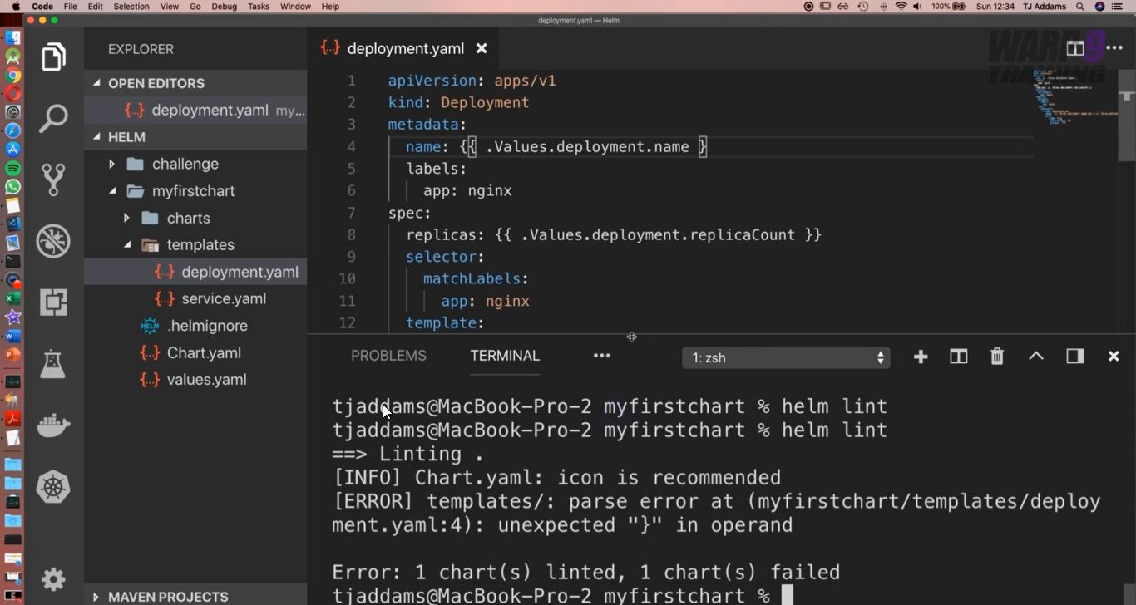

If you remove deployment in the 4th line then if you execute the helm lint it will not show any error

So run the helm template . it will open the deployment file under the metadata name it is showing as a blank which we can see the below screenshot

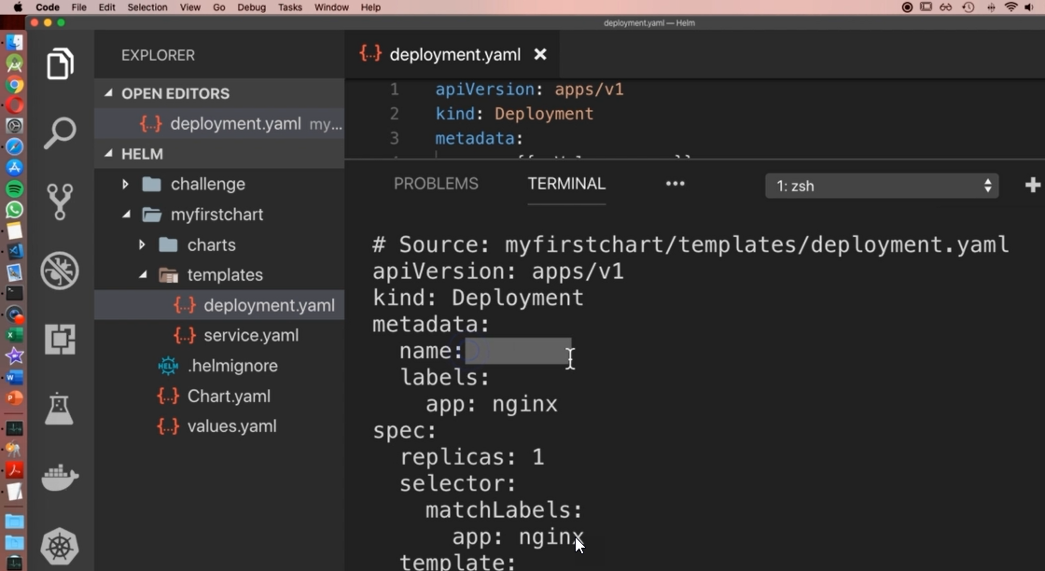

1. 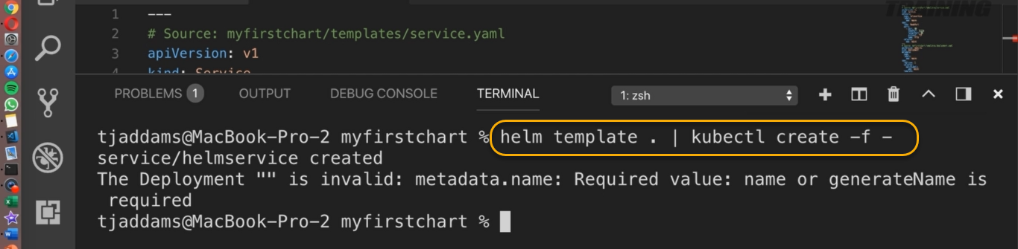

After f there is (-) which means And the dash is representing standard input.

So we take the output from Helme template and possibly execute creates it on the fly.

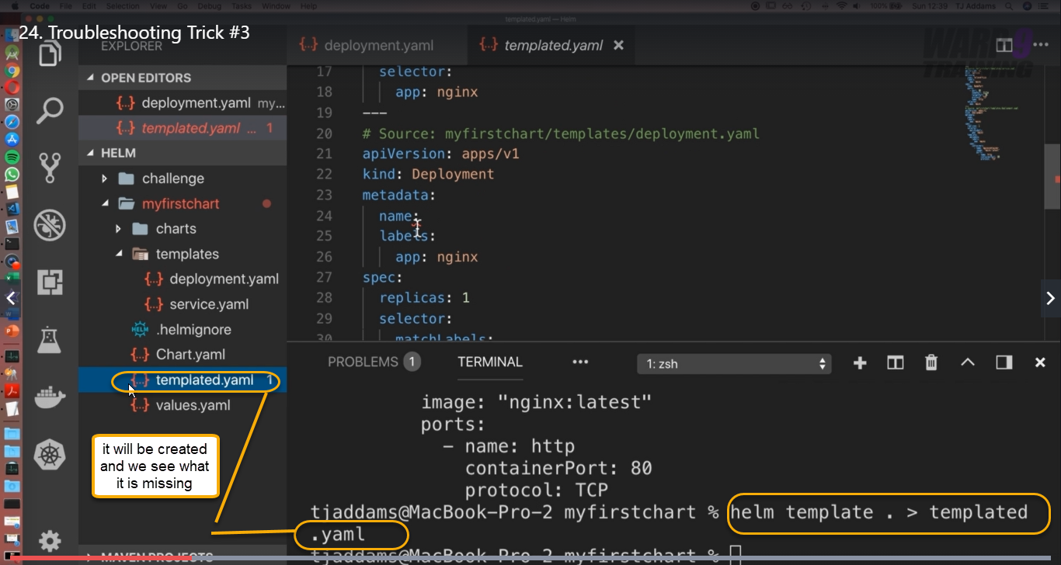

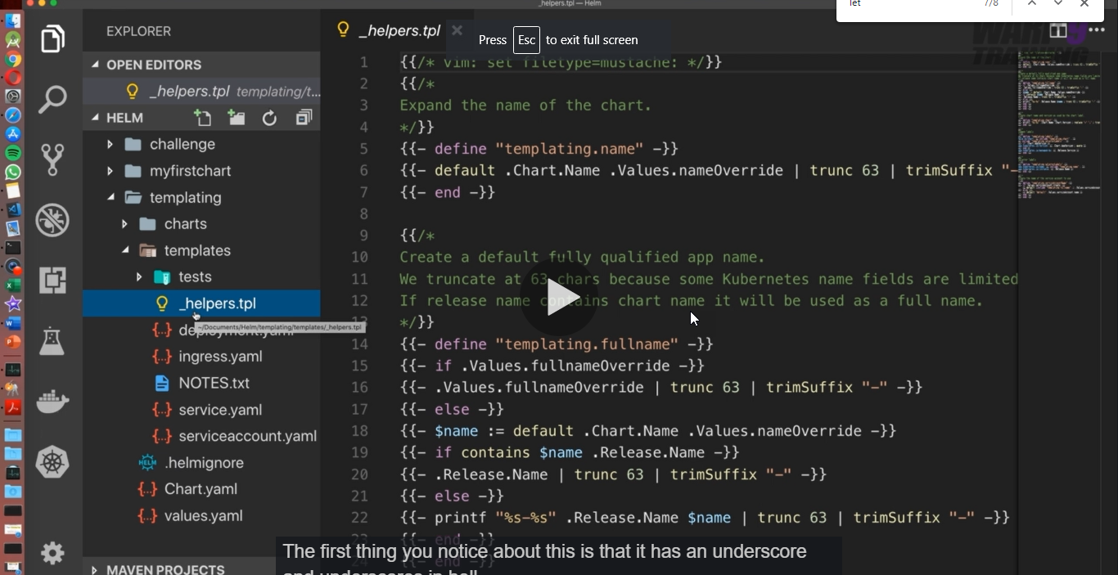

With respect to above (_helpers.tpl)The first thing you notice about this is that it has an underscore and underscores in helm.

Let it know this vault doesn't contain any kubernetes manifest when otherwise it doesn't contain any Kubernetes object.

To make the the comment use # or {{/* at starting and ending {{/* as we see above screenshot

Creating the template file

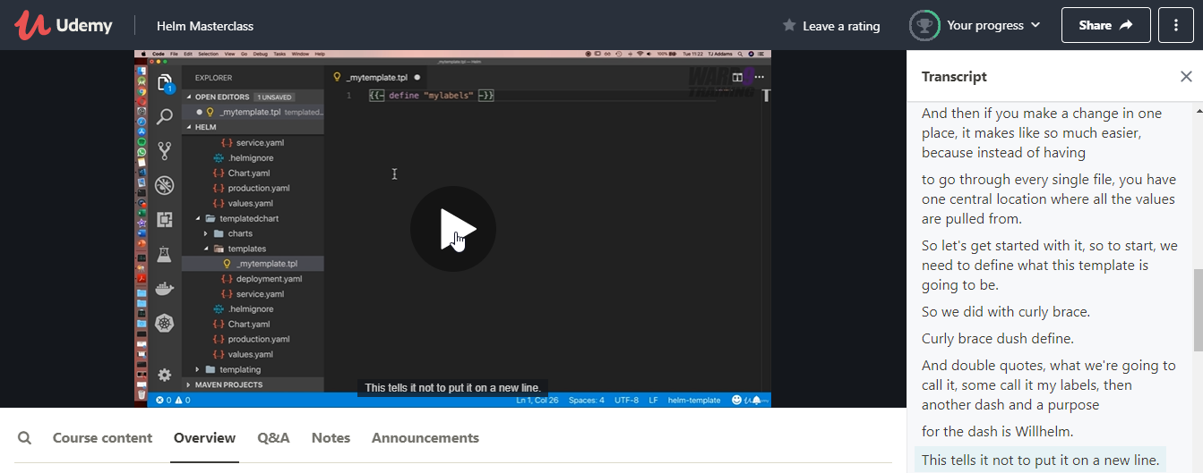

This tells it not to put it on a new line.

So we had multiple values in there.

What we do is then put in potentially a new line at the end of it which could break our Yamal.

So we don't want to do that.

The need to end a template book so good can embrace calibres.

Accessing Templates

We need to put in a dash now very, very important.

You need to remove the second one and you'll find out why very shortly.

So, again, here we have the two options we can even use template or we can use, include and include

will allow us to use the other Helme function, but allows us to indent.

You can't do this with template, so it makes more sense to always use include.

Next, we need to say what template or what part of a template do we want to include.

Now, as you can have multiple things in here, this defined label here and the name tells it what to

include as you can have multiple things inside.

That's what we have the name.

So in this case, we're going to use my labels.

And for whatever reason, if it doesn't work, is usually because there has been a misspelling and as

you can see here, of misspells it myself.

So let's go ahead and say this and just check that all matches.

Excellent.

Next, we need to include the context of where to paste a text because it's effectively what it's going

to do.

We would include is going to include the text and we need to tell it where to put it.

So in this case, we're going to use full stop to say right here, then we need to pass it into a function,

because if we leave it the way it is right now, what is going to do is put everything on a single line.

And this is going to give you a weird error about Jason to Yamal or Yamal to Jason conversion, because

what it will look like is something like this, which is invalid Yamal and invalid.

Jason, the come on we're going to use is called an indent, which stands for new line indentation where

we need to tell it how many lines to indent by.

As we saw before, App Engine X was invented by four spaces.

So we put forward.

And now if you're wondering why we didn't put the second dash in there, well, the purpose of that

dash is to tell Helm not to create a new line.

So it's a bit contradictory what we're trying to do here.

If we then put a dash in here, which would say create a new line followed by don't create a new line.

So by removing it, what it's going to do is take all the elements inside here in Denver by four spaces

and put each one on a new line.

So now let's go ahead and check this out.

Make sure to save a file, because if you go to a terminal and now let's run Helme templates, full

stop.

Excellent.

Let's make this bigger.

How awesome is that we can see a template in action, we have a labels, we have app location and front

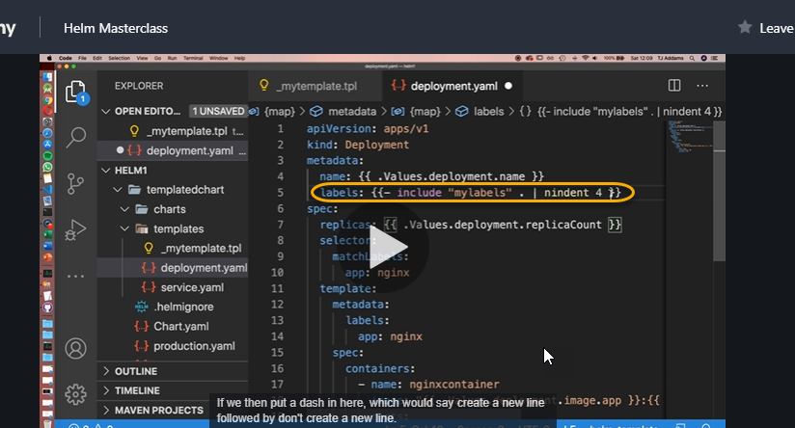

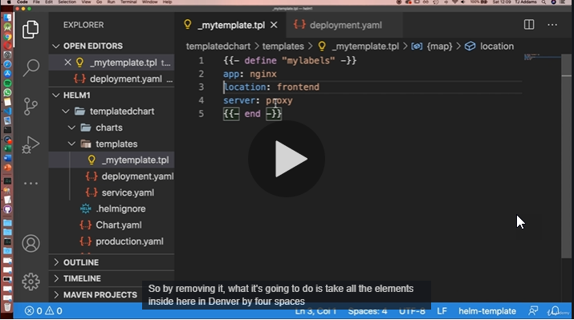

If we run the helm template .

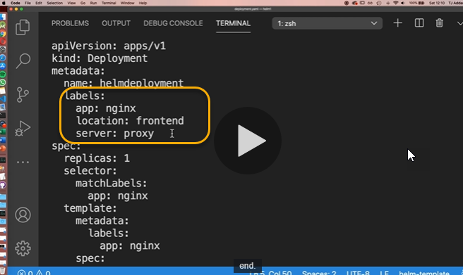

Advanced Templates

What if we had something we want to enable in certain environments, but not in others?

It'd be quite messy to keep it in the code. In this enable we are enabling proxy only in production.yaml

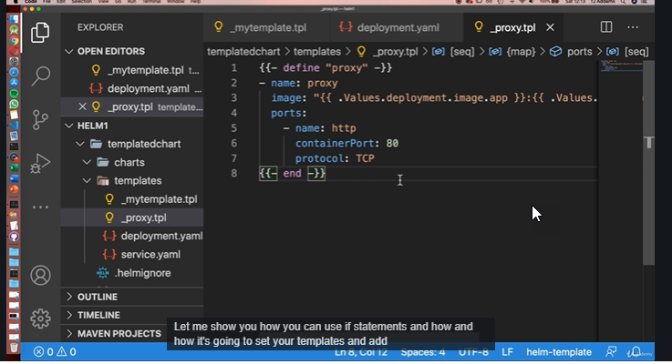

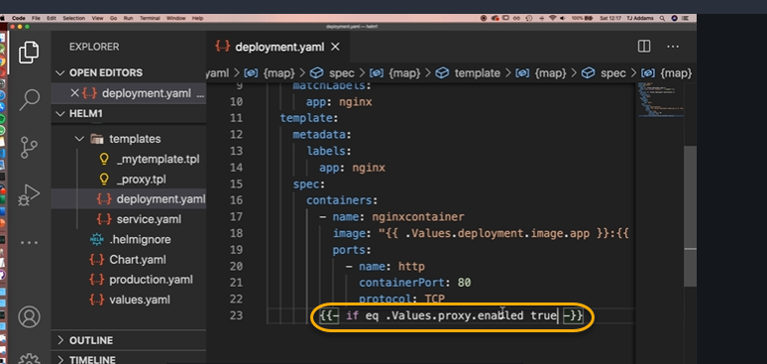

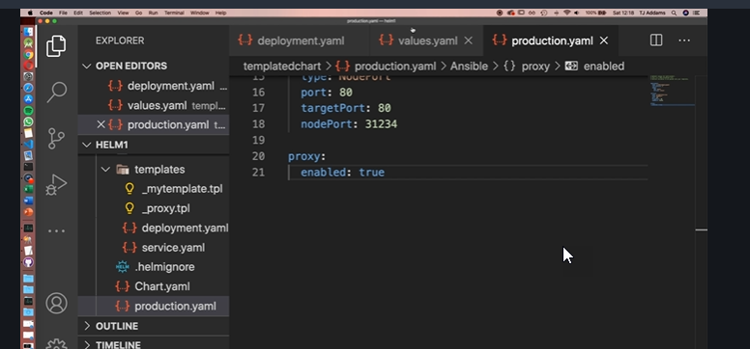

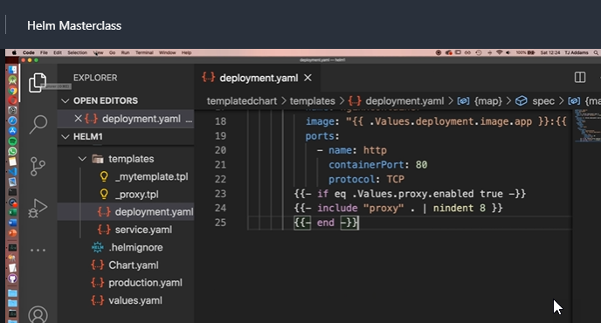

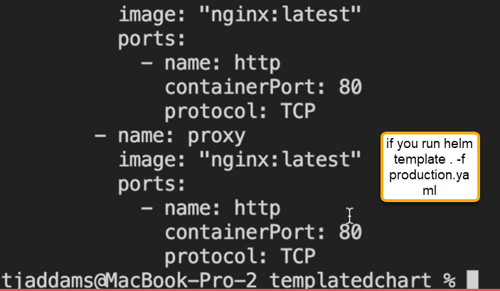

And if you run helm template .-f deployment.yaml proxy will NOT be appeared

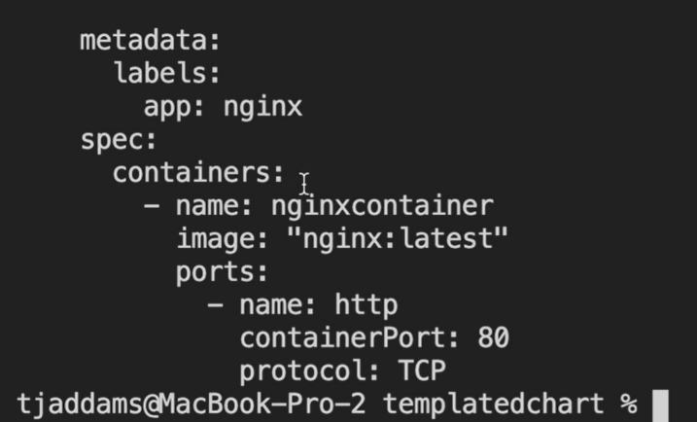

More information on flow control with Helm: [**https://helm.sh/docs/chart_template_guide/control_structures/**](https://helm.sh/docs/chart_template_guide/control_structures/)

Operators you can use with Helm: [**https://helm.sh/docs/chart_template_guide/functions_and_pipelines/#operators-are-functions**](https://helm.sh/docs/chart_template_guide/functions_and_pipelines/#operators-are-functions)

If you want to use else we can use the and the format is below one

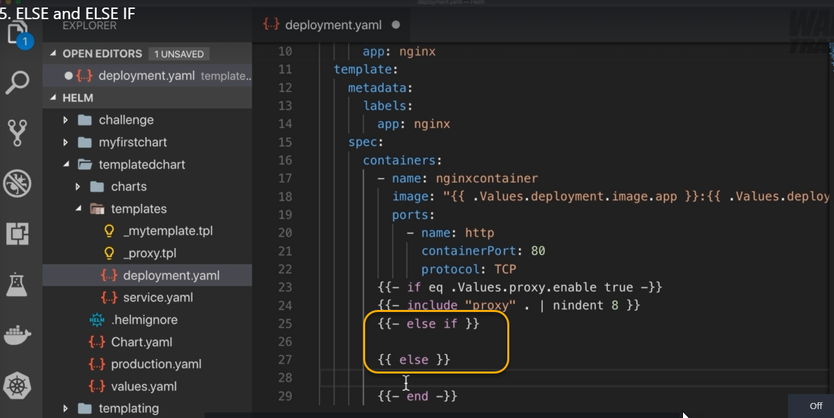

More information on flow control with Helm: [**https://helm.sh/docs/chart_template_guide/control_structures/**](https://helm.sh/docs/chart_template_guide/control_structures/)

Operators you can use with Helm: [**https://helm.sh/docs/chart_template_guide/functions_and_pipelines/#operators-are-functions**](https://helm.sh/docs/chart_template_guide/functions_and_pipelines/#operators-are-functions)

